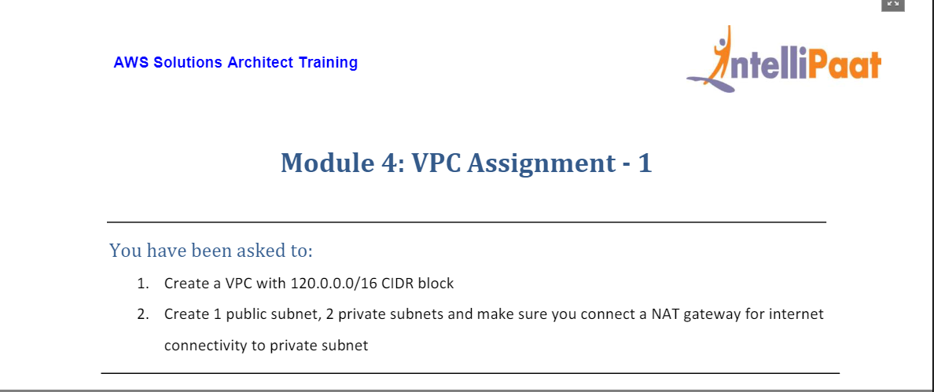

* Created Mod4VPC VPC with IPv4 CIDR as 120.0.0.0/16

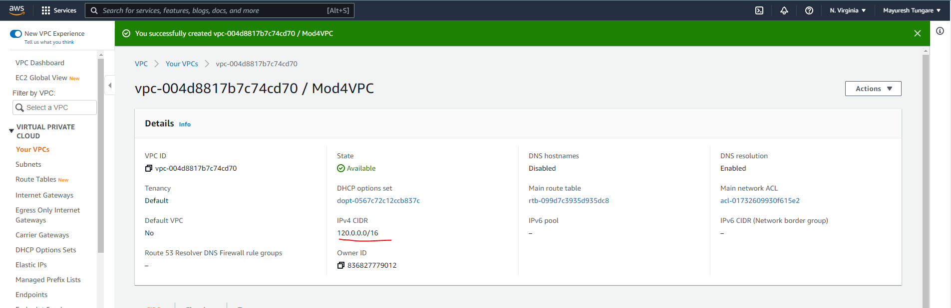

* Created three subnets (Subnet 1a, Subnet 2b, Subnet 3c)

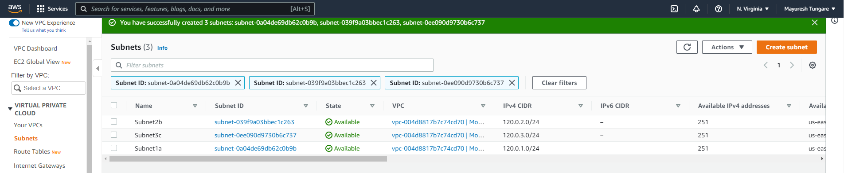

* Created two Route Tables (PublicRT and PrivateRT)

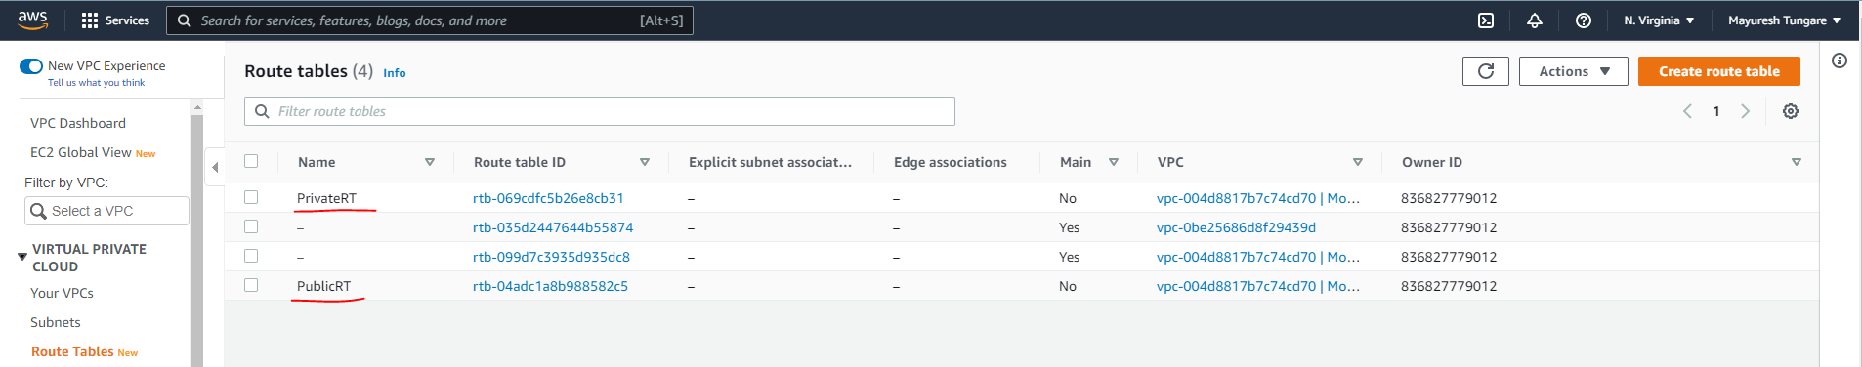

* Create Internet Gateway (Mod4IGW) and attach it to the VPC

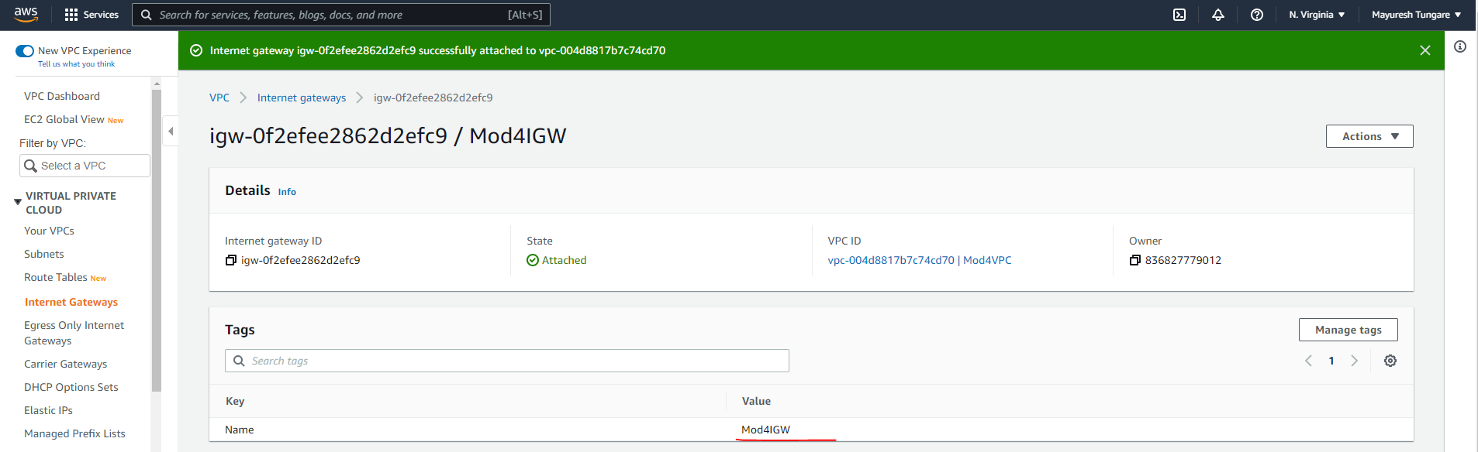

* Now Subnet1a is associated with Public RT and made public.

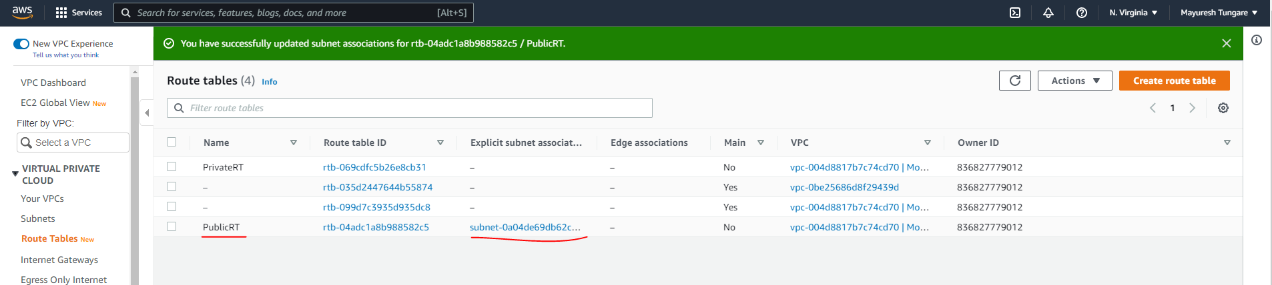

* Now internet connectivity is enabled for PublicRT and consequently Subnet1a.

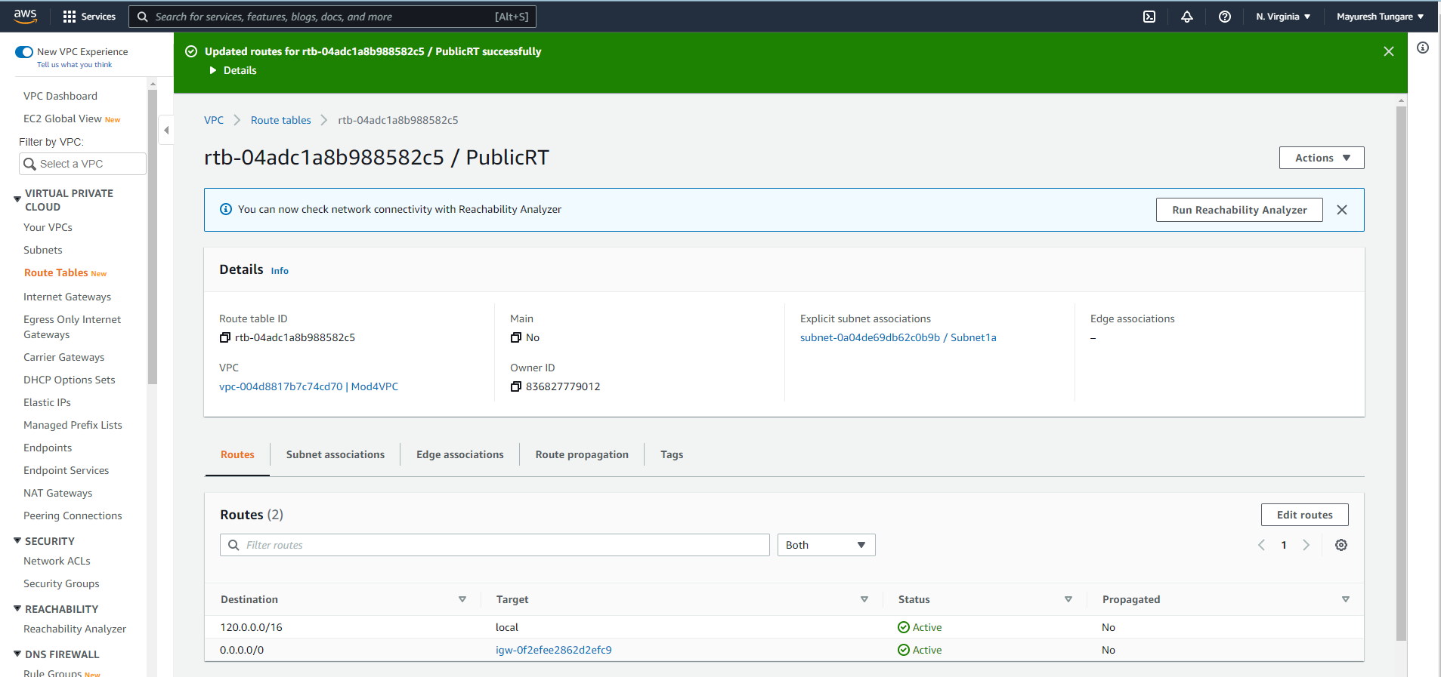

* Now Subnet2b and Subnet3c is associated with PrivateRT.

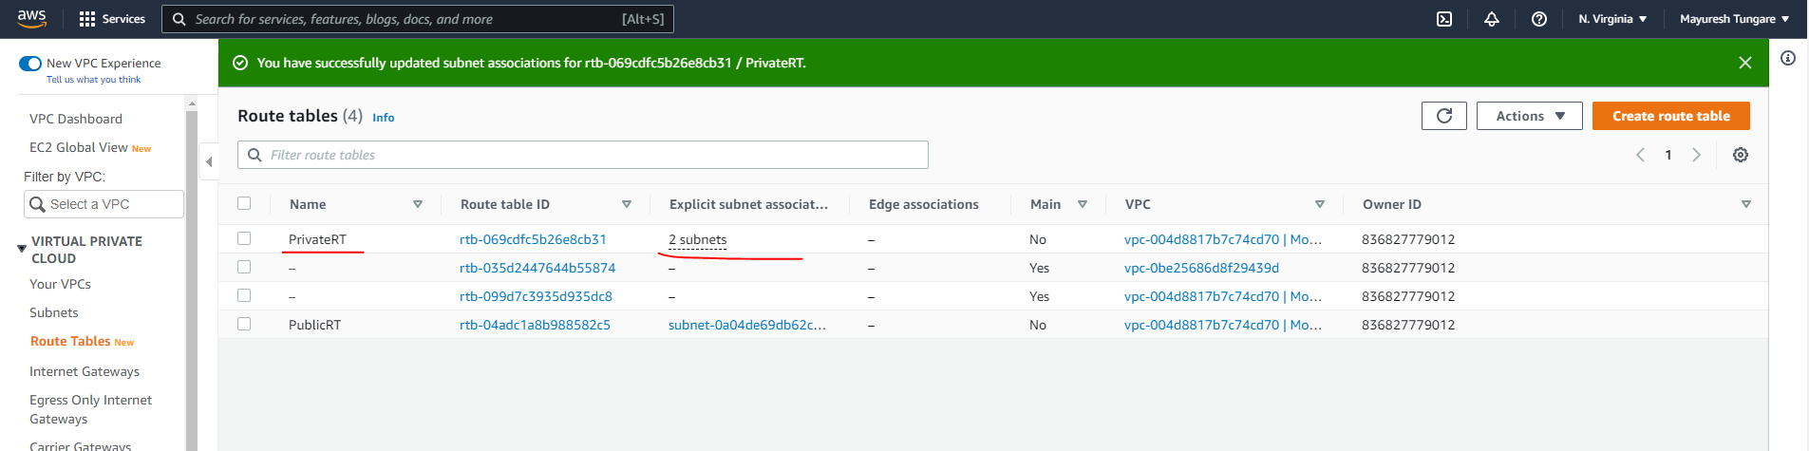

* Now we will use NAT instance to connect with private subnet. Firstly, we create NAT instance

*(I am not using NAT Gateway as it is a chargeable service.)*

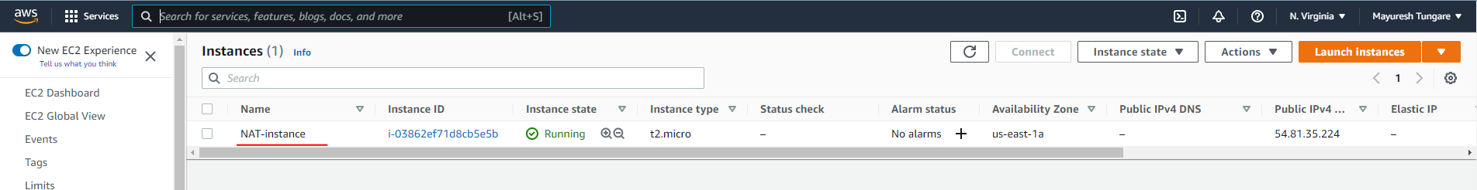

* Now add NAT instance (which is placed in public subnet – Subnet1a) to the Route table of private subnet.

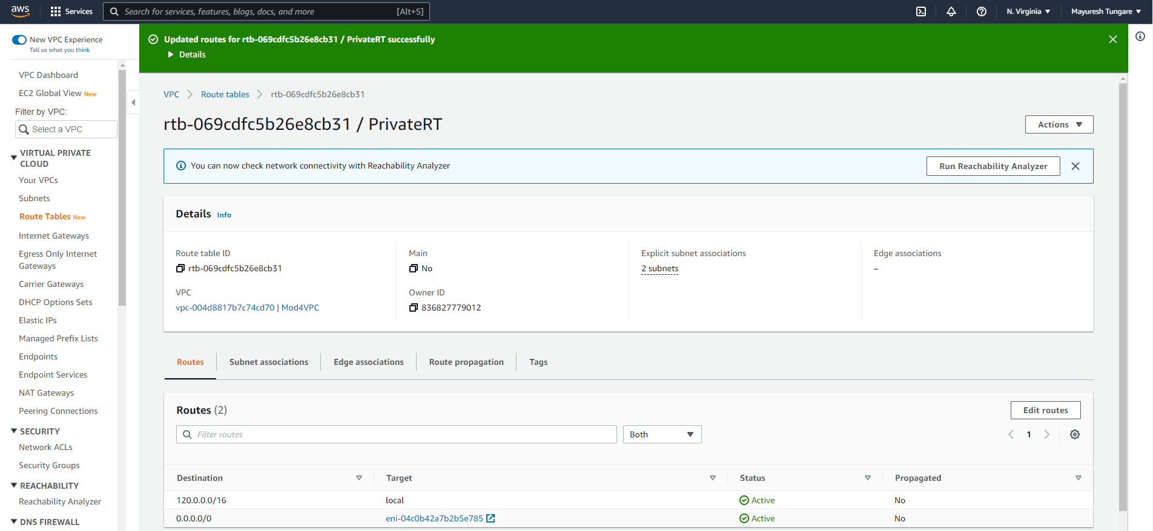

Assignment is now complete.